Login (1) – Fix
The login system was improved by checking the username and password against the expected stored values before allowing access. It makes sure only the right username and password can log in instead of just trusting whatever the user types. Without this check anyone could get in. I also added a limit of 3 tries so someone cannot keep guessing forever. This is safer because it actually checks who is logging in and makes it harder to break in.
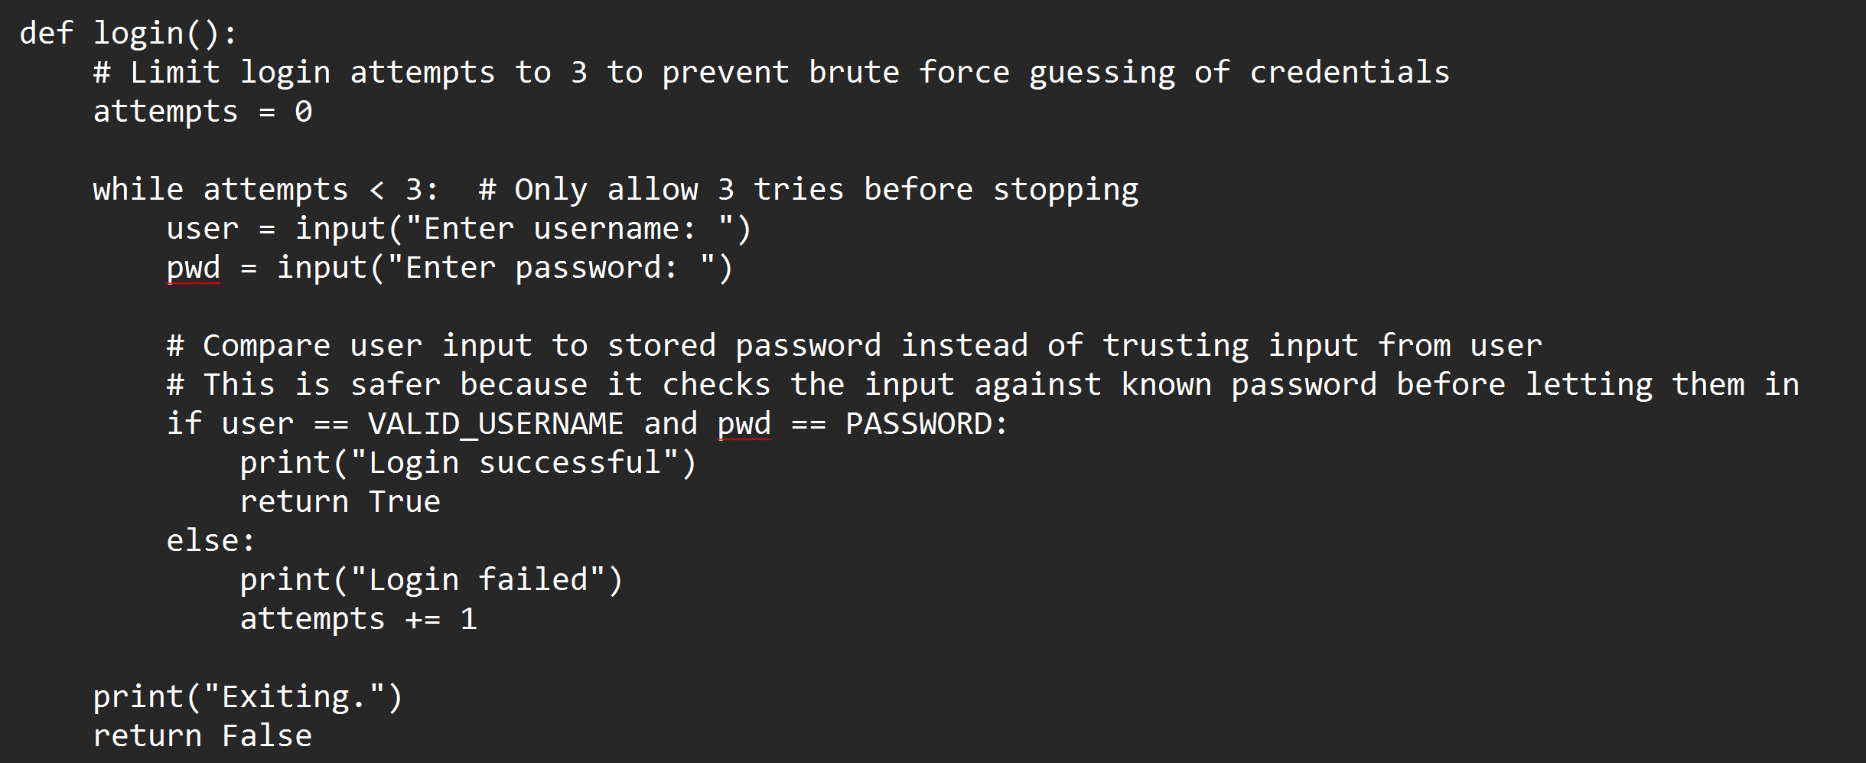

Run System Command (2) – Fix
The program was changed to only allow a small list of safe commands instead of running anything the user types. It now checks the input against an allowed list like "whoami" and "dir" before running it. As a side note, what is considered "safe" was not clearly defined for this application. Some commands might be safe in one program but not in another. I picked simple commands like "whoami" and "dir" because they are basic and low risk, but this list could be changed later as needed for the programs needs. If the command is not allowed, it gets blocked. This is safer because it prevents harmful commands from being executed and removes full system control from the user.
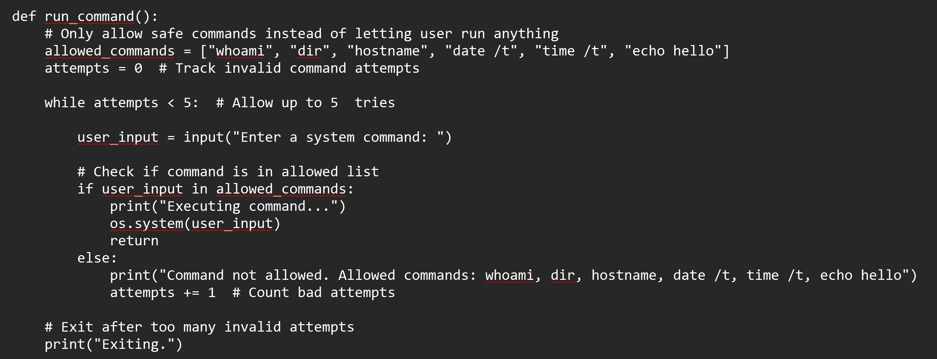

Deserialize Data (3) – Fix
The deserialize feature was improved by adding input validation, length limits, and error handling. It now rejects empty input, limits how long the input can be, and only allows simple data types like strings, numbers, lists, and dictionaries. It also uses error handling so the program does not crash on bad input. This is safer because it lowers the risk of malicious data being processed, but it is not a full fix. Pickle can still be dangerous with user input, and the safest real fix would be to not use pickle here at all. For this phase of the project, I did not want to get rid of what was given and change it completely, so I made it as safe as I think I could.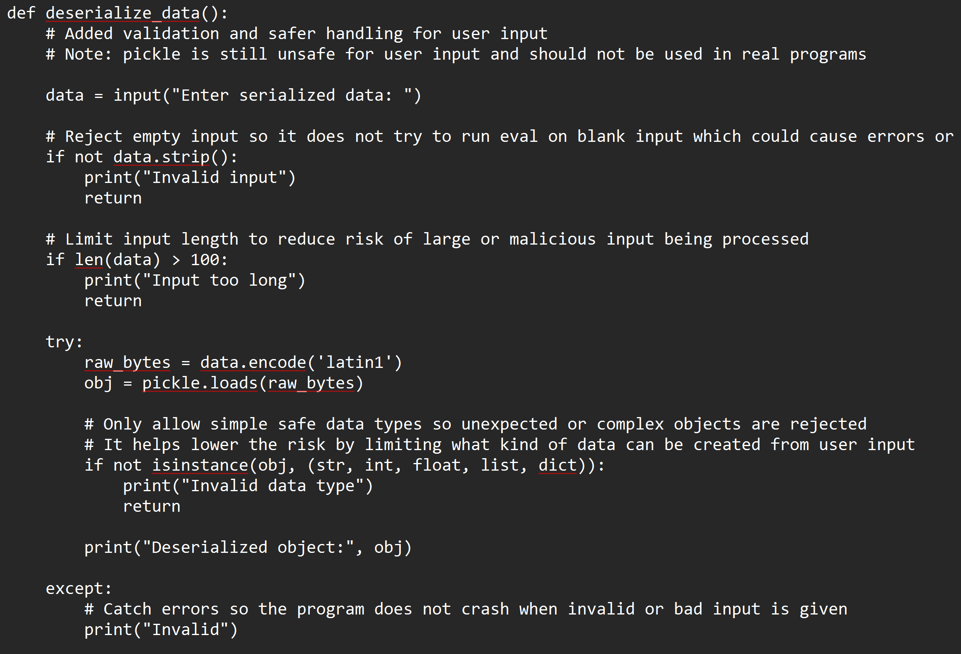

Unsafe Eval (4) – Fix
I changed eval so it only works with simple math. The program checks that the input only has numbers and basic math symbols before running it. If anything else is in the input, it gets blocked. This is safer because it stops people from running real Python code and only lets them do simple math.

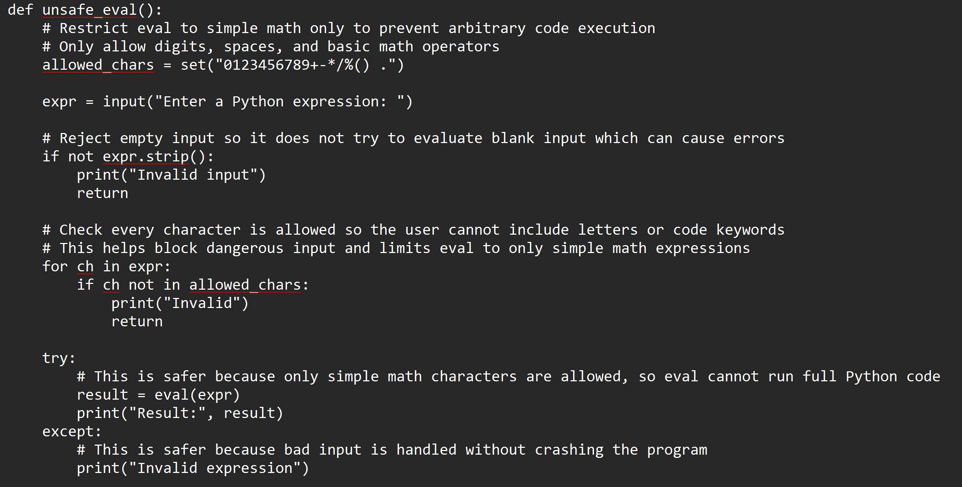

Write File (5) – Fix
The file writing feature was restricted so the user can only create simple text files. The program now only allows a filename (no paths), forces a .txt extension, and saves the file to a fixed location (Desktop). This is safer because it prevents the user from creating dangerous files or writing files anywhere on the system. Even if someone typed in Steal_data.py it would just end up as Steal_data.py.txt and be saved to the desktop.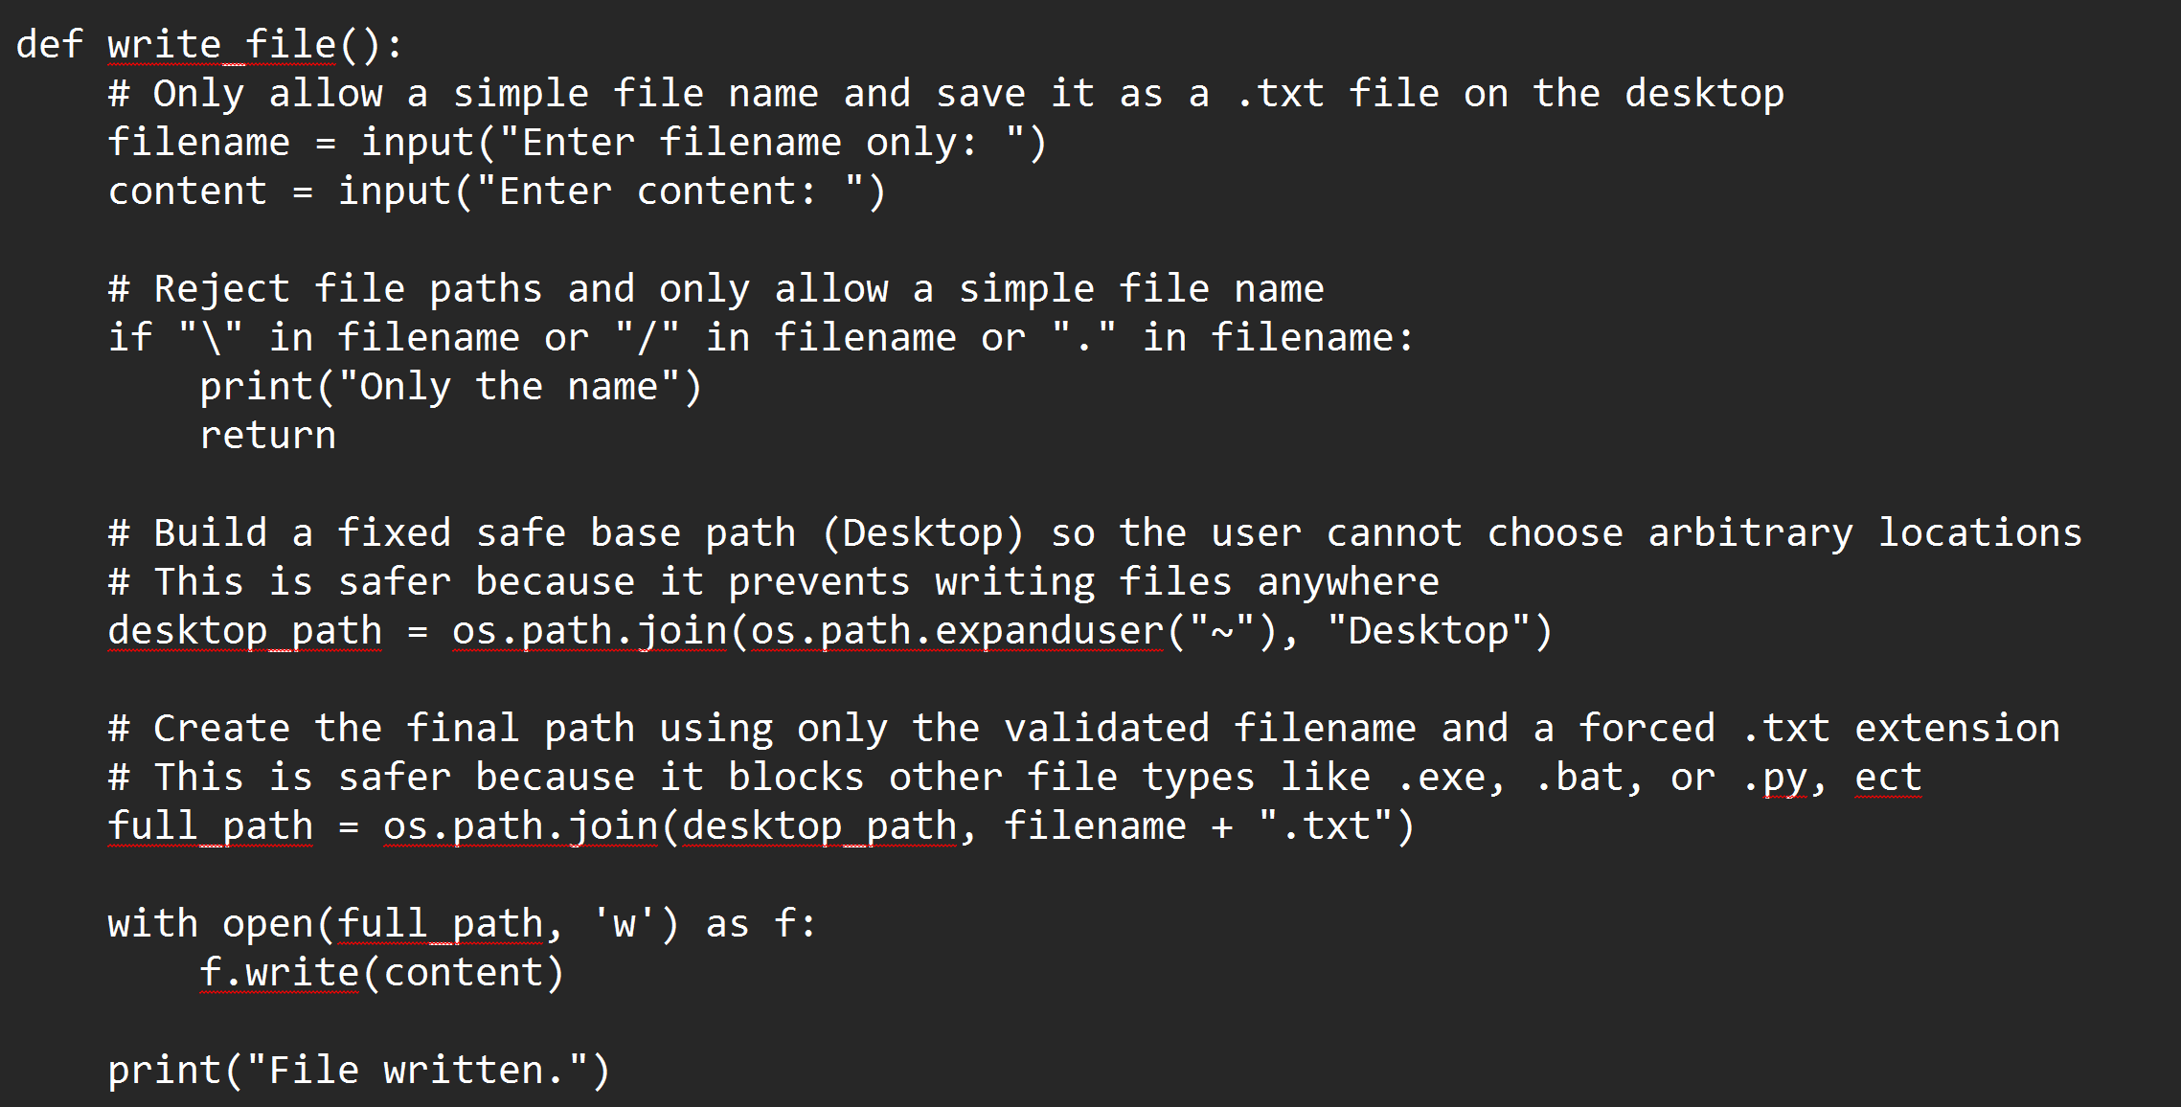

Start Backdoor (6) – Fix
The backdoor feature was made safer by limiting it to the local machine only and removing command execution. The program now binds to 127.0.0.1 instead of 0.0.0.0 which prevents external devices from connecting. It also adds a timeout so it doesn't wait forever and it no longer runs commands from the connection. This is safer because it removes remote access and prevents attackers from controlling the system.
